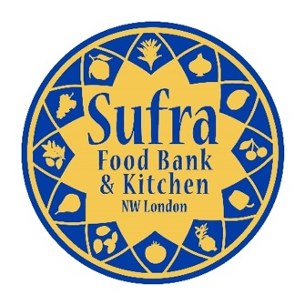
Registration Form
FOOD ACADEMY
160 Pitfield Way, Stonebridge, London, NW10 0PW
www.sufra-nwlondon.org.uk
Registered Charity No. 1151911

Child/Young Person’s Details
First name: |  |  |  | Surname:

Address:
 |  |  |  | Postcode:
Date of birth: |  |  |  | Gender:
Telephone number: |  |  |  | E-mail address:

Emergency Contact Details
Name: |  |  |  | Relationship:
Telephone number: |  |  |  | E-mail address:
Name: |  |  |  | Relationship:
Telephone number: |  |  |  | E-mail address:

Child/Young Person’s Ethnicity
White British |  |  |  |  | Asian – Bangladeshi
White Irish |  |  |  |  | Other Asian Background*
White Other |  |  |  |  | Chinese
Black Caribbean or British Caribbean |  |  |  |  | Mixed – White and Black Caribbean
Black African or British African |  |  |  |  | Mixed – White and Black African
Other Black background* |  |  |  |  | Mixed – White and Asian
Asian – Indian |  |  |  |  | Other Mixed Background*
Asian – Pakistani |  |  |  |  | Other Ethnic Background*
*if other, please indicate

Child/Young Person’s Faith
Christianity |  |  |  |  | Buddhism
Judaism |  |  |  |  | Hinduism
Islam |  |  |  |  | Sikhism
No religion |  |  |  |  | Other:

Child/Young Person’s Medical Conditions & Dietary Preferences

Do you suffer from any medical conditions/disability? Yes No

Do you have any dietary preferences? Yes No

If yes to EITHER question above, please provide more details so that we can make reasonable adjustments:

How did you hear about us?
Sufra E-Mail/Mailing List |  |  |  |  | School
Family/Friend |  |  |  |  | Local Organisation/Charity

If other, please provide more details:

Declaration
- 1. I agree to my child taking part in the activities of the Academy.
- 2. I agree to pay a £10 deposit to confirm registration, which will be returned at the end of the course. Your child’s place on the course will NOT be confirmed until receipt of payment.
- 3. I confirm to the best of my knowledge that my son/daughter does not suffer from any medical condition other than those listed above.
- I give permission for Sufra NW London to take photographs during the course for publicity purposes and reporting to funders.
- 5. I understand that Sufra NW London accept no responsibility for loss, damage or injury caused by or during attendance of organised activities except where such loss, damage or injury can be shown to result directly from the negligence of the Charity.

Payment Options:

Cash payment submitted to a member of staff at the office.

Cheque payable to “Sufra NW London” and posted to the office.

Bank Transfer to Sufra NW London
(Sort Code: 40-46-10 and Account Number 01537881 with Reference: FOODACAD)

Credit Card payment via our website donation button
Parent/Guardian Signature: |  |  |  |  |  | Date:
Payment Method: |  |  |  |  |  | Payment Date:

