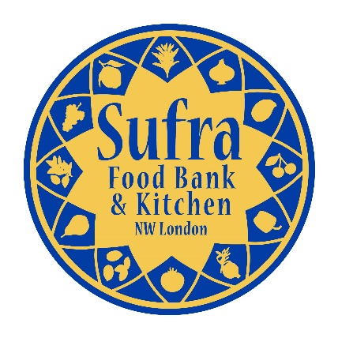
Registration Form
FOOD ACADEMY
160 Pitfield Way, Stonebridge, London, NW10 0PW
www.sufra-nwlondon.org.uk
Registered Charity No. 1151911

Child/Young Person’s Details
First name: |  |  |  | Surname:

Address:
 |  |  |  | Postcode:
Date of birth: |  |  |  | Gender:
Telephone number: |  |  |  | E-mail address:

Emergency Contact Details (if under 16 years)
Name: |  |  |  | Relationship:
Telephone number: |  |  |  | E-mail address:
Name: |  |  |  | Relationship:
Telephone number: |  |  |  | E-mail address:

Child/Young Person’s Ethnicity
White British |  |  |  | Asian – Bangladeshi
White Irish |  |  |  | Other Asian Background*
White Other |  |  |  | Chinese
Black Caribbean or British Caribbean |  |  |  | Mixed – White and Black Caribbean
Black African or British African |  |  |  | Mixed – White and Black African
Other Black background* |  |  |  | Mixed – White and Asian
Asian – Indian |  |  |  | Other Mixed Background*
Asian – Pakistani |  |  |  | Other Ethnic Background*
*if other, please indicate

Child/Young Person’s Faith
Christianity |  |  |  | Buddhism
Judaism |  |  |  | Hinduism
Islam |  |  |  | Sikhism
No religion |  |  |  | Other:

Child/Young Person’s Medical Conditions & Dietary Preferences

Do you suffer from any medical conditions/disability? Yes No

Do you have any dietary preferences? Yes No

If yes to EITHER question above, please provide more details so that we can make reasonable adjustments:

How did you hear about us?
Sufra E-Mail/Mailing List |  |  |  | School
Family/Friend |  |  |  | Local Organisation/Charity

If other, please provide more details:

Declaration
- I agree to pay a £10 deposit to confirm registration which will be returned at the end of the course. Your place on the course will NOT be confirmed until receipt of payment.
- I understand that my child is expected to attend ALL sessions of the course in order for the deposit to be returned)
- I give permission for Sufra NW London to take photographs during the course for publicity purposes and reporting to funders.

Payment Options:

Cash payment submitted to a member of staff at the office.

Cheque payable to “Sufra NW London” and posted to the office.

Bank Transfer to Sufra NW London
(Sort Code: 40-46-10 and Account Number 01537881 with Reference: FOODACAD)

Credit Card payment via our website donation button
Parent/Guardian Signature: |  |  |  |  | Date:
Payment Method: |  |  |  |  | Payment Date:

